- A ball of mass m1= 5kg and a block of mass m2= 13kg are attached by a lightweight cord that passes over a frictionless pulley of negligible mass, as shown in Figure-1. The block lies on a frictionless incline of angle(θ = 48⁰). Find the magnitude of the acceleration of the two objects and the tension in the cord.
- When two objects of unequal mass are hung vertically over a frictionless pulley of negligible mass. Determine the magnitude of the acceleration of the two objects and the tension in the lightweight cord. m1 = 4kg and m2 =9.5kg
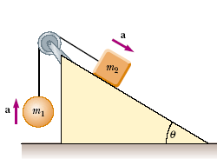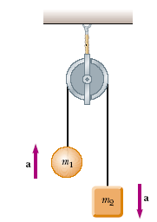
Fig-1 Fig-2
- A baseball player with mass 79kg, sliding into a base is slowed by a force of friction of 470N. What is the coefficient of kinetic friction between the player and the ground?
- The coefficient of static friction between the tires of a car and a dry road is 0.62. The mass of the car is 1500kg.What maximum braking force is obtainable (a) on a level road and (b) on an 8.6º downgrade?
- A hockey puck having a mass of 0.50 kg slides on the horizontal, frictionless surface of an ice rink. Two forces act on the puck, as shown in Figure-3. The force F1 has a magnitude of 3.5.0 N, and the force F2 has a magnitude of 7.5.0 N. Determine both the magnitude and the direction of the puck’s acceleration.
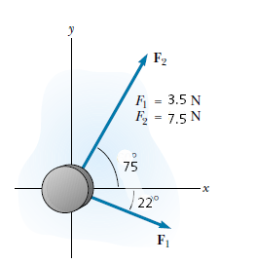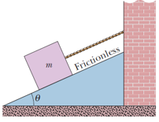
Fig-3 Fig-4

- In Fig. 4 let the mass of the block be 8.5 kg and the angle be 30.Find (a) the tension in the cord and (b) the normal force acting on the block. (c) If the cord is cut, find the magnitude of the resulting acceleration of the block.

- In the following Figure-5, a block of mass = 3.0 kg slides along a floor while a force F of magnitude 12.0 N is applied to it at an upward angel ϴ. The coefficient of kinetic friction between the block and the floor is μ = 0. 40. (We can vary ϴ from 0 to 90, but block still remain on the floor). What vale of ϴ gives the maximum value of the lock’s acceleration magnitude “a” ? Calculate.
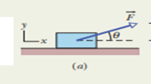 Fig-5

